Chapter 3
Exercise 1
3.10 Compare and contrast the if single-selection statement and the while repetition statement. How are these two statements similar? How are they different?

How They’re Similar
Similarity | Explanation
Both use boolean conditions | Each statement checks a condition that evaluates to true or false.
Both control program flow | They determine what code runs and when, based on logic.
Both can contain any valid block of statements | Inside {}, you can have variable updates, method calls, or even other control structures.
Both may skip code execution | If the condition is false initially, the code block inside doesn’t execute at all.
How They’re Different
Feature | if Statement | while Statement
Type | Selection (decision-making) | Repetition (looping)
Execution | Executes once if condition is true | Executes repeatedly while condition remains true
Condition re-evaluation | Condition is checked once | Condition is checked before each iteration
Typical use | Choose between alternative actions | Perform an action until a condition changes
May cause infinite loop | No — executes once only | Yes, if the condition never becomes false

3.11 Explain what happens when a Java program attempts to divide one integer by another. What happens to the fractional part of the calculation? How can you avoid that outcome?
The fractional part is discarded, not rounded.
To keep the fractional part, at least one operand must be a floating-point type (float or double).
3.12 Describe the two ways in which control statements can be combined.

1. Nesting (placing one control statement inside another)
This means one control statement appears inside the body of another.
👉 In other words, you “nest” one structure inside another to form more specific or layered conditions.

2. Sequential (placing control statements one after another)
This means executing multiple control statements in sequence, one after another — not nested, but lined up in order.

3.13 What type of repetition would be appropriate for calculating the sum of the first 100 positive integers? What type would be appropriate for calculating the sum of an arbitrary number of positive integers? Briefly describe how each of these tasks could be performed.

Problem 1: Sum of the first 100 positive integers

✅ Appropriate repetition type:
A counter-controlled repetition (using a for loop).

💡 Why:
You know in advance exactly how many times (100) the loop must execute — once for each integer from 1 to 100.
That’s what makes a for loop ideal — it’s designed for when the number of iterations is known before the loop begins.

🧮 How it can be performed:
int sum = 0;
for (int i = 1; i <= 100; i++) {
sum = sum + i; // or sum += i;
}
System.out.println("The sum of the first 100 positive integers is " + sum);

Problem 2: Sum of an arbitrary number of positive integers

✅ Appropriate repetition type:
A sentinel-controlled repetition (often using a while loop).

💡 Why:
Here, you don’t know in advance how many numbers the user will enter.
The loop must continue until the user provides some special input value (a sentinel) — for example, entering 0 or -1 to stop.

🧮 How it can be performed:
import java.util.Scanner;

public class SumOfIntegers {
public static void main(String[] args) {
Scanner input = new Scanner(System.in);
int number;
int sum = 0;

System.out.print("Enter a positive integer (0 to stop): ");
number = input.nextInt();

while (number != 0) { // sentinel value is 0
sum = sum + number;
System.out.print("Enter next positive integer (0 to stop): ");
number = input.nextInt();
}

System.out.println("The sum is " + sum);
}
}

3.14 What is the difference between preincrementing and postincrementing a variable?

1. Preincrement (++x)
- The variable is incremented first, before it’s used in the expression.
- The incremented value is what the expression sees.

2. Postincrement (x++)
- The variable’s current value is used in the expression first,
and then the variable is incremented after the expression.

3.15 Identify and correct the errors in each of the following pieces of code. [Note: There may be more than one error in each piece of code.]
a) if (age >= 65);
System.out.println("Age is greater than or equal to 65");
else System.out.println("Age is less than 65)";
if (age >= 65) {
System.out.println("Age is greater than or equal to 65");
} else {
System.out.println("Age is less than 65");
}
b) int x = 1, total;
while (x <= 10) {
total += x; ++x;
}
int x = 1, total = 0;
while (x <= 10) {
total += x;
++x;
}
c) while (x <= 100)
total += x; ++x; d)
while (y > 0) {
System.out.println(y);
++y;
while (x <= 100) {
total += x;
++x;
}

Exercise 2
3.17 (Gas Mileage)
Drivers are concerned with the mileage their automobiles get. One driver has kept track of several trips by recording the miles driven and gallons used for each tankful. Develop a Java application that will input the miles driven and gallons used (both as integers) for each trip. The program should calculate and display the miles per gallon obtained for each trip and print the combined miles per gallon obtained for all trips up to this point. All averaging calculations should produce floating-point results. Use class Scanner and sentinel-controlled repetition to obtain the data from the user.
import java.util.Scanner;

public class MileageCalculator {
public static void main(String[] args) {
Scanner input = new Scanner(System.in);

int miles; // miles driven per trip
int gallons; // gallons used per trip
double milesPerGallon; // mpg for one trip
double totalMiles = 0; // sum of all miles
double totalGallons = 0; // sum of all gallons

System.out.print("Enter miles driven (-1 to quit): ");
miles = input.nextInt();

// Sentinel-controlled while loop
while (miles != -1) {
System.out.print("Enter gallons used: ");
gallons = input.nextInt();

milesPerGallon = (double) miles / gallons;
System.out.printf("Miles per gallon for this trip: %.2f%n", milesPerGallon);

// Update totals
totalMiles += miles;
totalGallons += gallons;

// Compute and display overall MPG so far
System.out.printf("Combined miles per gallon so far: %.2f%n%n",
totalMiles / totalGallons);

// Prompt for the next trip
System.out.print("Enter miles driven (-1 to quit): ");
miles = input.nextInt();
}

System.out.println("\nThank you! Program terminated.");
}
}
3.18 (Credit Limit Calculator)
Develop a Java application that determines whether any of several department-store customers has exceeded the credit limit on a charge account. For each customer, the following facts are available:
a) account number
b) balance at the beginning of the month
c) total of all items charged by the customer this month
d) total of all credits applied to the customer’s account this month
e) allowed credit limit.
The program should input all these facts as integers, calculate the new balance (= beginning balance + charges – credits), display the new balance and determine whether the new balance exceeds the customer’s credit limit. For those customers whose credit limit is exceeded, the program should display the message "Credit limit exceeded".
import java.util.Scanner;

public class CreditCheck {
public static void main(String[] args) {
Scanner input = new Scanner(System.in);

int accountNumber;
int beginningBalance;
int charges;
int credits;
int creditLimit;
int newBalance;

// Sentinel-controlled loop: -1 to stop
System.out.print("Enter account number (-1 to quit): ");
accountNumber = input.nextInt();

while (accountNumber != -1) {
System.out.print("Enter beginning balance: ");
beginningBalance = input.nextInt();

System.out.print("Enter total charges this month: ");
charges = input.nextInt();

System.out.print("Enter total credits this month: ");
credits = input.nextInt();

System.out.print("Enter allowed credit limit: ");
creditLimit = input.nextInt();

// Calculate new balance
newBalance = beginningBalance + charges - credits;

// Display new balance
System.out.println("New balance: " + newBalance);

// Check credit limit
if (newBalance > creditLimit) {
System.out.println("Credit limit exceeded");
}

System.out.println(); // Blank line for readability

// Prompt for next customer
System.out.print("Enter account number (-1 to quit): ");
accountNumber = input.nextInt();
}

System.out.println("Program terminated.");
}
}
3.19 (Sales Commission Calculator)
A large company pays its salespeople on a commission basis. The salespeople receive $200 per week plus 9% of their gross sales for that week. For example, a salesperson who sells $5,000 worth of merchandise in a week receives $200 plus 9% of $5000, or a total of $650. You’ve been supplied with a list of the items sold by each salesperson. The values of these items are as follows:
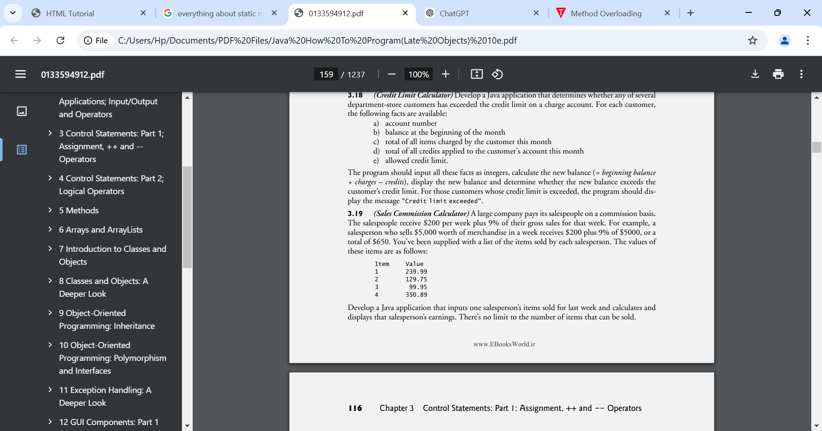

Develop a Java application that inputs one salesperson’s items sold for last week and calculates and displays that salesperson’s earnings. There’s no limit to the number of items that can be sold.
import java.util.Scanner;

public class SalesCommission {
public static void main(String[] args) {
Scanner input = new Scanner(System.in);

final double BASE_PAY = 200.0;
final double COMMISSION_RATE = 0.09;

double totalSales = 0.0;
int item;

System.out.println("Enter item numbers sold (1-4). Enter 0 to finish:");

while (true) {
System.out.print("Item number: ");
item = input.nextInt();

if (item == 0) {
break; // Sentinel: stop input
}

switch (item) {
case 1:
totalSales += 239.99;
break;
case 2:
totalSales += 129.75;
break;
case 3:
totalSales += 99.95;
break;
case 4:
totalSales += 350.89;
break;
default:
System.out.println("Invalid item number. Please enter 1–4 or 0 to finish.");
}
}

double earnings = BASE_PAY + (COMMISSION_RATE * totalSales);

System.out.printf("Total earnings for the week: $%.2f%n", earnings);
}
}
3.20 (Salary Calculator)
Develop a Java application that determines the gross pay for each of three employees. The company pays straight time for the first 40 hours worked by each employee and time and a half for all hours worked in excess of 40. You’re given a list of the employees, their number of hours worked last week and their hourly rates. Your program should input this information for each employee, then determine and display the employee’s gross pay. Use class Scanner to input the data.
import java.util.Scanner;

public class GrossPayCalculator {
public static void main(String[] args) {
Scanner input = new Scanner(System.in);

final int NUM_EMPLOYEES = 3;
final int REGULAR_HOURS = 40;
final double OVERTIME_RATE = 1.5;

for (int i = 1; i <= NUM_EMPLOYEES; i++) {
System.out.printf("Enter employee %d name: ", i);
String name = input.nextLine();

System.out.printf("Enter hours worked by %s: ", name);
double hoursWorked = input.nextDouble();

System.out.printf("Enter hourly rate for %s: ", name);
double hourlyRate = input.nextDouble();

double grossPay;

if (hoursWorked <= REGULAR_HOURS) {
grossPay = hoursWorked * hourlyRate;
} else {
double overtimeHours = hoursWorked - REGULAR_HOURS;
grossPay = (REGULAR_HOURS * hourlyRate) + (overtimeHours * hourlyRate * OVERTIME_RATE);
}

System.out.printf("Gross pay for %s: $%.2f%n%n", name, grossPay);

input.nextLine(); // Consume newline left-over
}
}
}
3.21 (Find the Largest Number)
The process of finding the largest value is used frequently in computer applications. For example, a program that determines the winner of a sales contest would input the number of units sold by each salesperson. The salesperson who sells the most units wins the contest. Write a pseudocode program, then a Java application that inputs a series of 10 integers and determines and prints the largest integer. Your program should use at least the following three variables:
a) counter: A counter to count to 10 (i.e., to keep track of how many numbers have been input and to determine when all 10 numbers have been processed).
b) number: The integer most recently input by the user.
c) largest: The largest number found so far.
import java.util.Scanner;

public class LargestNumber {
public static void main(String[] args) {
Scanner input = new Scanner(System.in);

int counter = 1;
int number;
int largest;

// Read the first number
System.out.print("Enter integer #" + counter + ": ");
number = input.nextInt();
largest = number;

// Process remaining 9 numbers
while (counter < 10) {
counter++;
System.out.print("Enter integer #" + counter + ": ");
number = input.nextInt();

if (number > largest) {
largest = number;
}
}

System.out.println("The largest number is " + largest);
}
}
3.22 (Tabular Output) Write a Java application that uses looping to print the following table of values:
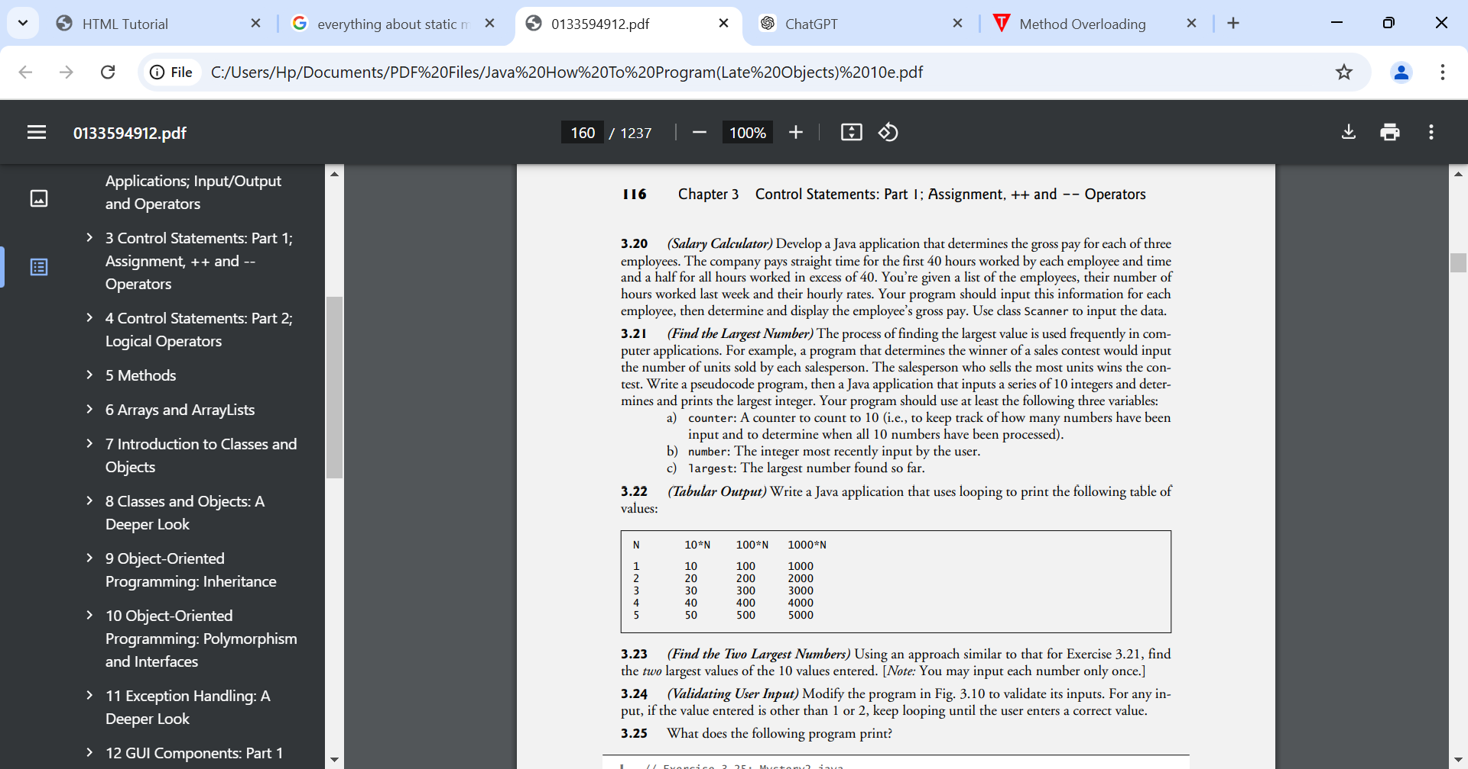
public class TableOfValues {
public static void main(String[] args) {
System.out.println("Number\tSquare\tCube"); // Table header
System.out.println("-----------------------");

// Loop through numbers 0 to 10
for (int i = 0; i <= 10; i++) {
int square = i * i;
int cube = i * i * i;

System.out.printf("%d\t%d\t%d%n", i, square, cube);
}
}
}
3.23 (Find the Two Largest Numbers) Using an approach similar to that for Exercise 3.21, find the two largest values of the 10 values entered. [Note: You may input each number only once.]
import java.util.Scanner;

public class TwoLargestNumbers {
public static void main(String[] args) {
Scanner input = new Scanner(System.in);

int number;
int largest = Integer.MIN_VALUE; // smallest possible integer
int secondLargest = Integer.MIN_VALUE;

for (int i = 1; i <= 10; i++) {
System.out.print("Enter integer #" + i + ": ");
number = input.nextInt();

if (number > largest) {
secondLargest = largest;
largest = number;
} else if (number > secondLargest) {
secondLargest = number;
}
}

System.out.println("Largest number: " + largest);
System.out.println("Second largest number: " + secondLargest);
}
}
3.24 (Validating User Input) Modify the program in Fig. 3.10 to validate its inputs. For any input, if the value entered is other than 1 or 2, keep looping until the user enters a correct value.

3.25 (Checkerboard Pattern of Asterisks)
Write an application that uses only the output statements
System.out.print("* ");
System.out.print(" ");
System.out.println(); to display the checkerboard pattern that follows. A System.out.println method call with no arguments causes the program to output a single newline character. [Hint: Repetition statements are required.]
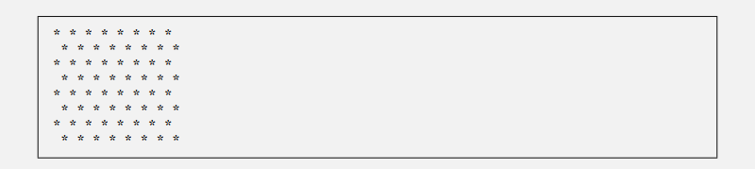
public class CheckerboardPattern {
public static void main(String[] args) {
int rows = 8; // number of rows
int cols = 8; // number of columns

for (int i = 1; i <= rows; i++) { // outer loop for rows
for (int j = 1; j <= cols; j++) { // inner loop for columns
if ((i + j) % 2 == 0) {
System.out.print("* "); // print asterisk on even positions
} else {
System.out.print(" "); // print space on odd positions
}
}
System.out.println(); // move to next row
}
}
}
Making a Difference
3.38 (Enforcing Privacy with Cryptography)
The explosive growth of Internet communications and data storage on Internet-connected computers has greatly increased privacy concerns. The field of cryptography is concerned with coding data to make it difficult (and hopefully—with the most advanced schemes—impossible) for unauthorized users to read. In this exercise you’ll investigate a simple scheme for encrypting and decrypting data. A company that wants to send data over the Internet has asked you to write a program that will encrypt it so that it may be transmitted more securely. All the data is transmitted as four-digit integers. Your application should read a four-digit integer entered by the user and encrypt it as follows: Replace each digit with the result of adding 7 to the digit and getting the remainder after dividing the new value by 10. Then swap the first digit with the third, and swap the second digit with the fourth. Then print the encrypted integer. Write a separate application that inputs an encrypted four-digit integer and decrypts it (by reversing the encryption scheme) to form the original number. [Optional reading project: Research “public key cryptography” in general and the PGP (Pretty Good Privacy) specific public key scheme. You may also want to investigate the RSA scheme, which is widely used in industrial-strength applications.]
import java.util.Scanner;

public class EncryptFourDigit {
public static void main(String[] args) {
Scanner input = new Scanner(System.in);

System.out.print("Enter a four-digit integer to encrypt: ");
int number = input.nextInt();

// Extract each digit
int d1 = number / 1000; // first digit
int d2 = (number / 100) % 10; // second digit
int d3 = (number / 10) % 10; // third digit
int d4 = number % 10; // fourth digit

// Apply encryption transformation
d1 = (d1 + 7) % 10;
d2 = (d2 + 7) % 10;
d3 = (d3 + 7) % 10;
d4 = (d4 + 7) % 10;

// Swap first with third, second with fourth
int temp = d1;
d1 = d3;
d3 = temp;

temp = d2;
d2 = d4;
d4 = temp;

// Combine digits to get encrypted number
int encryptedNumber = d1 * 1000 + d2 * 100 + d3 * 10 + d4;
System.out.println("Encrypted number: " + encryptedNumber);
}
}
3.39 (World Population Growth)
World population has grown considerably over the centuries. Continued growth could eventually challenge the limits of breathable air, drinkable water, arable cropland and other limited resources. There’s evidence that growth has been slowing in recent years and that world population could peak sometime this century, then start to decline. For this exercise, research world population growth issues online. Be sure to investigate various viewpoints. Get estimates for the current world population and its growth rate (the percentage by which it’s likely to increase this year). Write a program that calculates world population growth each year for the next 75 years, using the simplifying assumption that the current growth rate will stay Print the results in a table. The first column should display the year from year 1 to year 75. The second column should display the anticipated world population at the end of that year. The third column should display the numerical increase in the world population that would occur that year. Using your results, determine the year in which the population would be double what it is today, if this year’s growth rate were to persist.
import java.util.Scanner;

public class WorldPopulationProjection {
public static void main(String[] args) {
Scanner input = new Scanner(System.in);

// Input or preset values
System.out.print("Enter current world population (integer): ");
long currentPopulation = input.nextLong();

System.out.print("Enter annual growth rate (as percent, e.g., 0.90): ");
double growthRatePercent = input.nextDouble();

double growthRate = growthRatePercent / 100.0; // convert percent to decimal

System.out.printf("%n%-6s %-20s %-20s%n", "Year", "Population End Yr", "Increase This Yr");
System.out.println("----------------------------------------------------------");

long population = currentPopulation;
int yearOfDouble = -1;

for (int year = 1; year <= 75; year++) {
long newPopulation = (long) Math.round(population * (1 + growthRate));
long increase = newPopulation - population;

System.out.printf("%-6d %-20d %-20d%n", year, newPopulation, increase);

// Check if doubled
if (yearOfDouble < 0 && newPopulation >= 2 * currentPopulation) {
yearOfDouble = year;
}

population = newPopulation;
}

if (yearOfDouble > 0) {
System.out.printf("%nAt this growth rate, the world population would double in year: %d%n", yearOfDouble);
} else {
System.out.println("\nThe world population would not double within 75 years at this growth rate.");
}

input.close();
}
}

